CS2023 - Data Structures and Algorithms

In-class Lab Exercise - Week 7

April 25, 2023

Name: A. C. Pasqual

Index No. : 200445V

Terminal Output

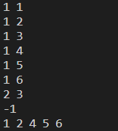

GitHub repository with code:

<https://github.com/Anuki16/cs2023-data-structures-algorithms/tree/master/Lab7>